Name: Varia Neel Jitesh
Enrollment No: 250447003019

Network Security And Forensics
Lab Session – 5
Program 3:
- Caesar Cipher Cryptosystem Demonstration
- Read plaintext input from a file (i.e. your First Name, Second Name)
- Encrypt the plaintext using Caesar Cipher algorithm
- Write the ciphertext output to another file

Algorithm
- Start
- Open the input file containing plain text
- Read the text
- Choose a shift key(K)
- For each character in the plaintext:
  - If character is alphabetic:
    - Convert it using
      - C = (P + K) mode 26
- Store the encrypted text
- Write the Cipher text into the output file
- Close both file
- Stop

P = Plain text
C = Ciphertext
K = Shift key
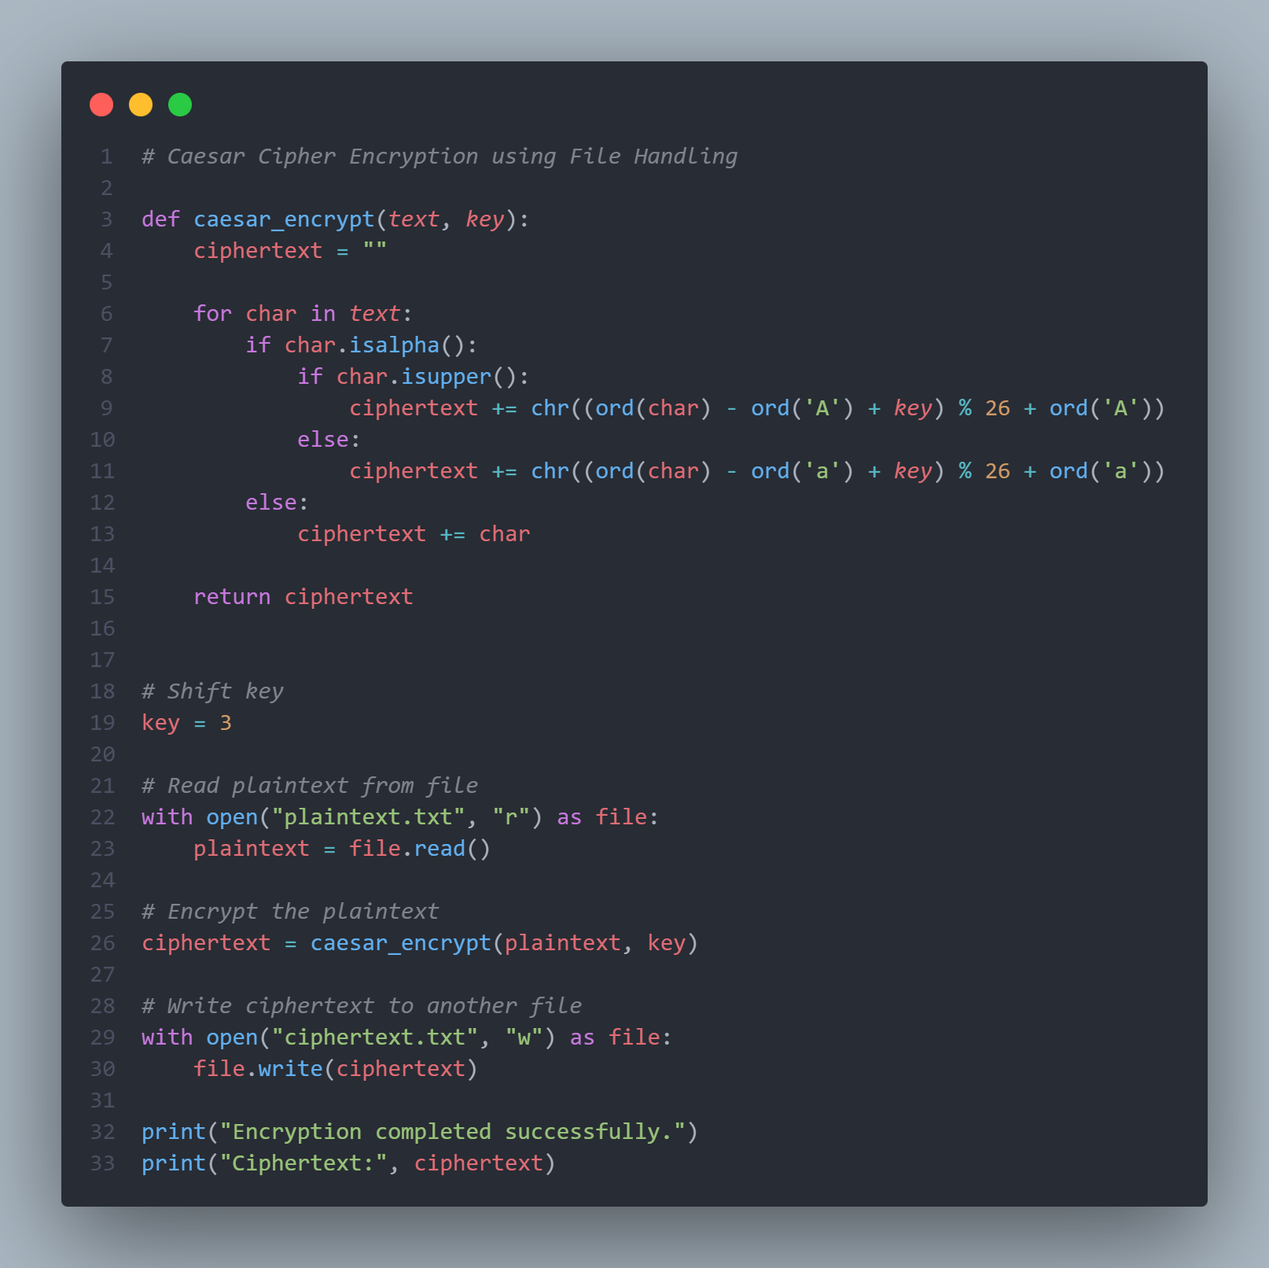

Code Runned output
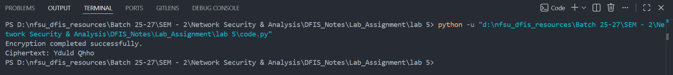

File input
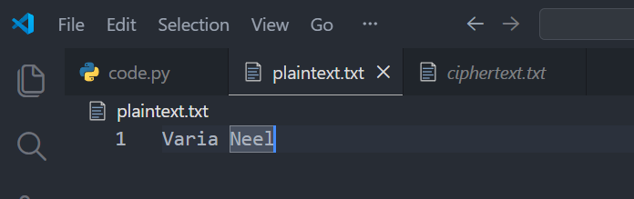

File output
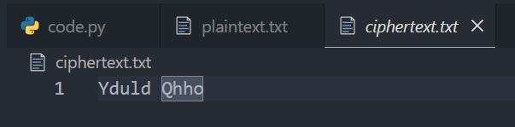

Program 4:
- Monoalphabetic Cipher Cryptosystem Demonstration
- Read plaintext input from a file (i.e. your First Name, Second Name)
- Encrypt the plaintext using Monoalphabetic Cipher algorithm

A Monoalphabetic Cipher replaces each plaintext letter with another fixed letter based on a substitution key.

Example substitution key:
Plain : ABCDEFGHIJKLMNOPQRSTUVWXYZ
Cipher: QWERTYUIOPASDFGHJKLZXCVBNM

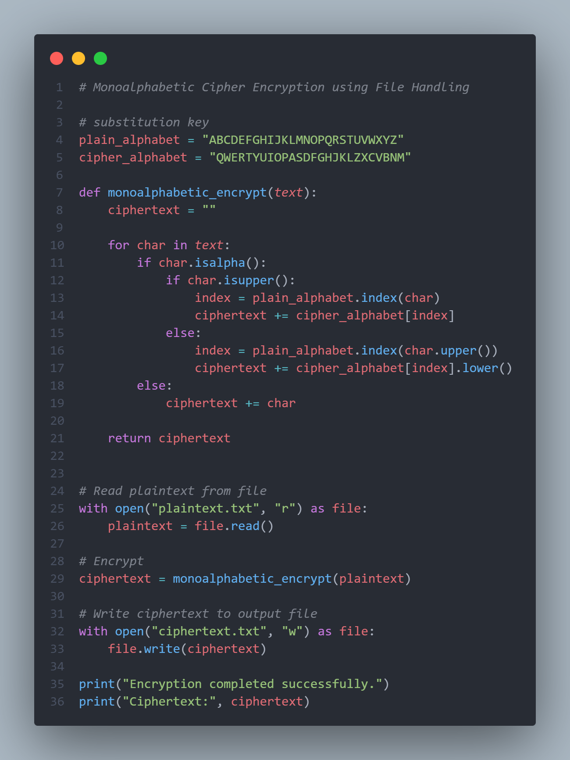

Terminal Output
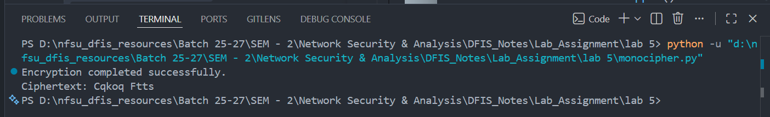

File Input


File Output
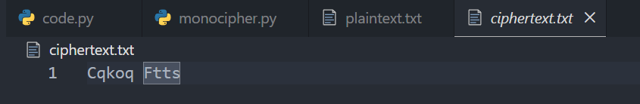

Program 5: Write a program to demonstrate the Vegner Cipher (Input from file)

The Vigenère Cipher is a polyalphabetic encryption technique where each plaintext letter is shifted according to a repeating keyword.

Encryption formula:
Ci = (Pi + Ki) mod 26

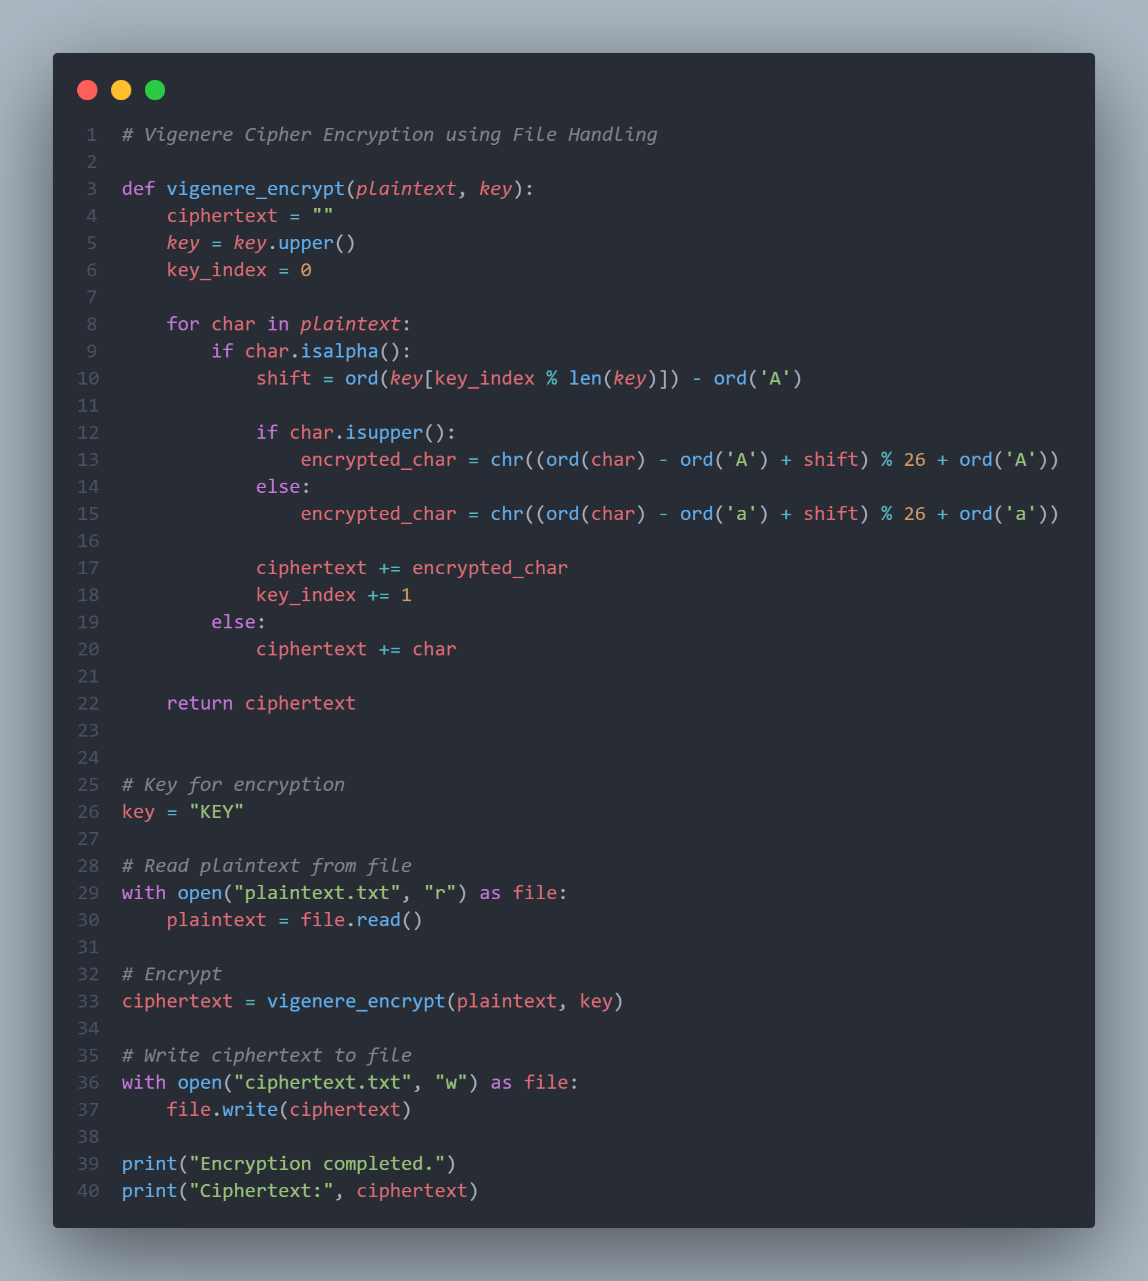

Terminal Output
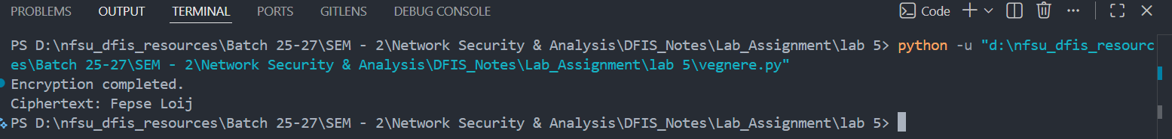
File Input


File Output
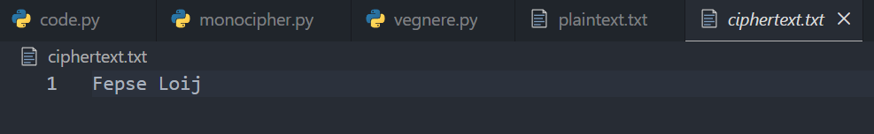

Program6: Write a Program to demonstrate the AutoKey Cipher.
Input from file
Output into the file
The Autokey Cipher is a variation of the Vigenère Cipher where the key is extended using the plaintext itself.
Encryption formula:
Ci = (Pi + Ki) mod 26

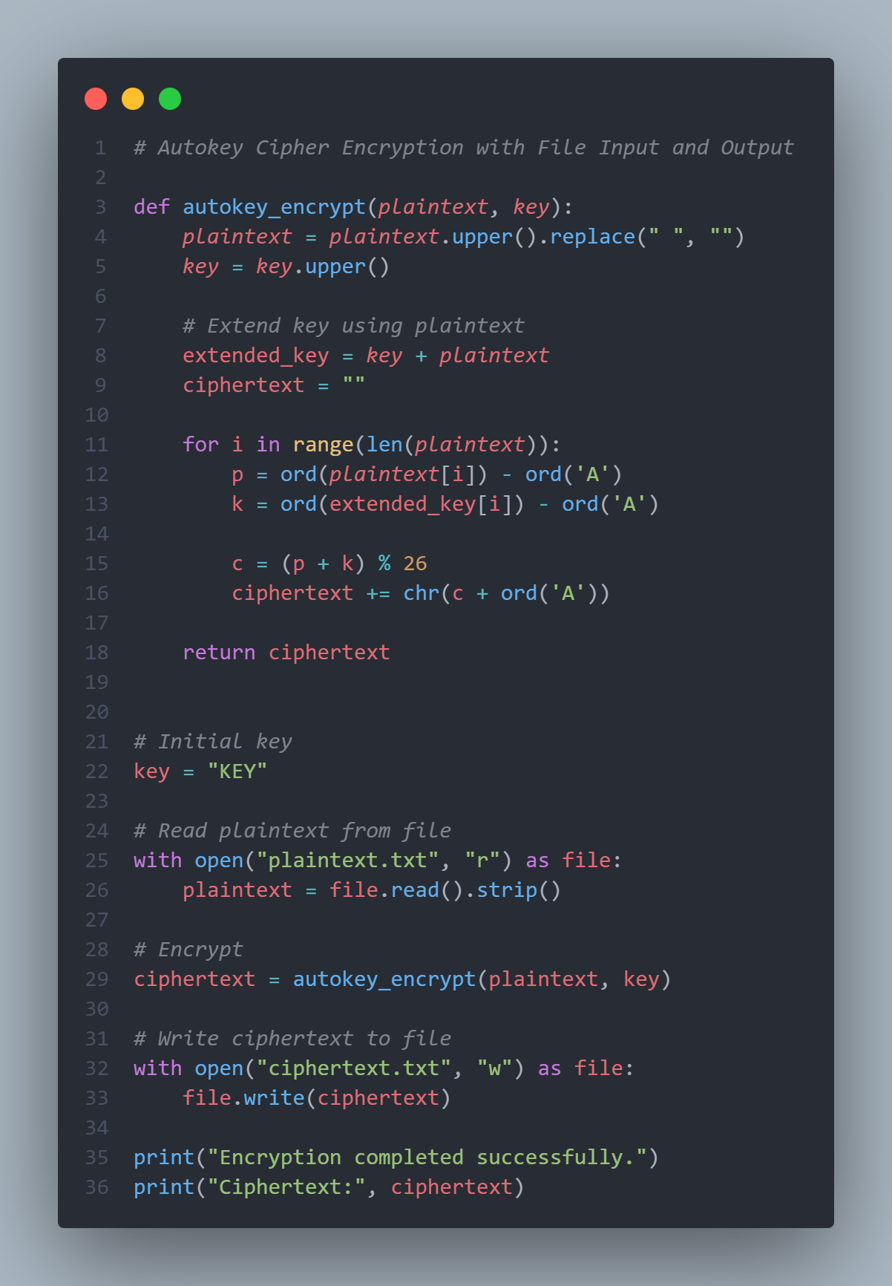
Terminal Output
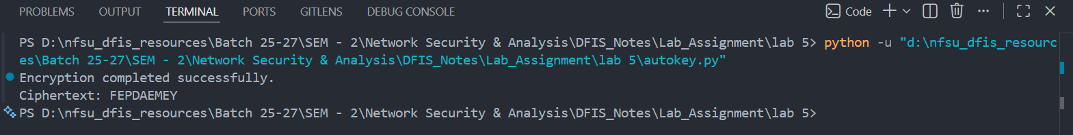

File Input


File Output
